CYCLE 5

1.) LIST VIEW

XML

<?xml version="1.0" encoding="utf-8"?>
<android.support.constraint.ConstraintLayout xmlns:android="http://schemas.android.com/apk/res/android"
xmlns:app="http://schemas.android.com/apk/res-auto"
xmlns:tools="http://schemas.android.com/tools"
android:layout_width="match_parent"
android:layout_height="match_parent"
tools:context=".MainActivity">

<TextView
android:id="@+id/textView"
android:layout_width="162dp"
android:layout_height="47dp"
android:layout_marginStart="8dp"
android:layout_marginLeft="8dp"
android:layout_marginEnd="8dp"
android:layout_marginRight="8dp"
android:text="Account"
app:layout_constraintEnd_toEndOf="parent"
app:layout_constraintStart_toStartOf="parent"
tools:layout_editor_absoluteY="64dp" />
<ListView
android:id="@+id/lv"
android:layout_width="368dp"
android:layout_height="321dp"
tools:layout_editor_absoluteX="8dp"
tools:layout_editor_absoluteY="131dp" />
</android.support.constraint.ConstraintLayout>
JAVA

package com.example.sjcet.myapplication;
import android.support.v7.app.AppCompatActivity;
import android.os.Bundle;
import android.widget.ArrayAdapter;
import android.widget.ListView;
public class MainActivity extends AppCompatActivity {
ListView lv;
@Override
protected void onCreate(Bundle savedInstanceState) {
super.onCreate(savedInstanceState);
setContentView(R.layout.activity_main);
lv=(ListView)findViewById(R.id.lv);
String[] courses={"MCA","MBA","BBA","BCA"};
ArrayAdapter adapter = new ArrayAdapter(this,android.R.layout.simple_list_item_1,courses);
lv.setAdapter(adapter);
}
}
OUTPUT

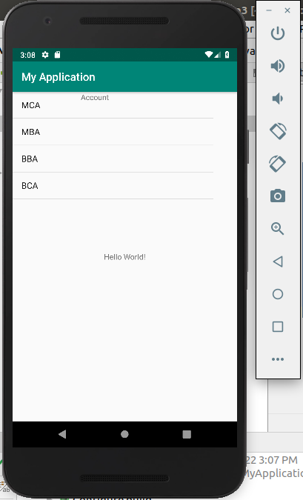

2.)LIST VIEW WITH TOAST

Activity_Main.xml

<?xml version="1.0" encoding="utf-8"?>
<android.support.constraint.ConstraintLayout xmlns:android="http://schemas.android.com/apk/res/android"
xmlns:app="http://schemas.android.com/apk/res-auto"
xmlns:tools="http://schemas.android.com/tools"
android:layout_width="match_parent"
android:layout_height="match_parent"
tools:context=".MainActivity">
<TextView
android:id="@+id/textView2"
android:layout_width="wrap_content"
android:layout_height="wrap_content"
app:layout_constraintBottom_toBottomOf="parent"
app:layout_constraintLeft_toLeftOf="parent"
app:layout_constraintRight_toRightOf="parent"
app:layout_constraintTop_toTopOf="parent" />
<TextView
android:id="@+id/tv"
android:layout_width="162dp"
android:layout_height="47dp"
android:layout_marginStart="8dp"
android:layout_marginLeft="8dp"
android:layout_marginEnd="8dp"
android:layout_marginRight="8dp"
android:text="Account"
app:layout_constraintEnd_toEndOf="parent"
app:layout_constraintStart_toStartOf="parent"
tools:layout_editor_absoluteY="64dp" />
<ListView
android:id="@+id/lv"
android:layout_width="368dp"
android:layout_height="321dp"
tools:layout_editor_absoluteX="8dp"
tools:layout_editor_absoluteY="131dp" />
</android.support.constraint.ConstraintLayout>

JAVA

Main_Activity.java
package com.example.sjcet.tostlistview;
import android.content.Intent;
import android.net.Uri;
import android.support.v7.app.AppCompatActivity;
import android.os.Bundle;
import android.view.Menu;
import android.view.MenuItem;
import android.view.View;
import android.widget.AdapterView;
import android.widget.ArrayAdapter;
import android.widget.ListView;
import android.widget.TextView;
import android.widget.Toast;
public class MainActivity extends AppCompatActivity implements AdapterView.OnItemClickListener {
TextView tv;
ListView lv;
@Override
protected void onCreate(Bundle savedInstanceState) {
super.onCreate(savedInstanceState);
setContentView(R.layout.activity_main);
tv=(TextView)findViewById(R.id.tv);
String msg=getIntent().getStringExtra("mykey");// receiving the data
tv.setText("welcome"+msg);
lv=(ListView)findViewById(R.id.lv);// display(welcom changing to admin)
// listvivew operation
String[] courses={"MCA","MBA","BBA","BCA"};
ArrayAdapter adapter = new ArrayAdapter(this,android.R.layout.simple_list_item_1,courses);
lv.setAdapter(adapter);
// attach listener
lv.setOnItemClickListener(this);//implement the method by alt+enter
}
@Override
public void onItemClick(AdapterView<?> adapterView, View view, int i, long l) {
String itemname=lv.getItemAtPosition(i).toString();
Toast.makeText(this,itemname,Toast.LENGTH_SHORT).show();
}
}
OUTPUT
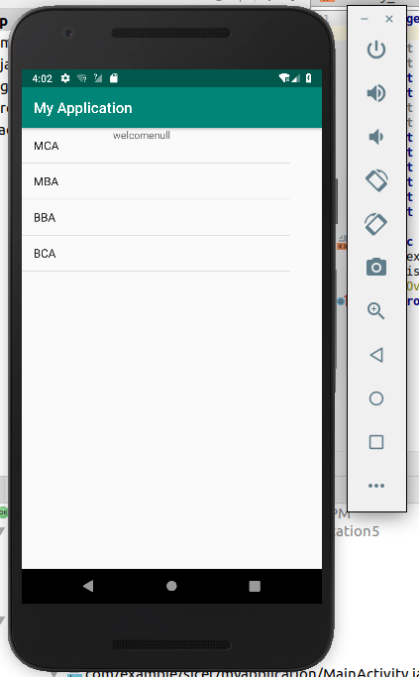

3.) GRID VIEW

xml

<?xml version="1.0" encoding="utf-8"?>
<android.support.constraint.ConstraintLayout
xmlns:android="http://schemas.android.com/apk/res/android"
xmlns:tools="http://schemas.android.com/tools"
xmlns:app="http://schemas.android.com/apk/res-auto"
android:layout_width="match_parent"
android:layout_height="match_parent"
tools:context=".MainActivity">
<GridView
android:id="@+id/gv"
android:layout_width="wrap_content"
android:layout_height="wrap_content"
android:columnWidth="100dp"
android:minHeight="100dp"
android:numColumns="auto_fit"
android:stretchMode="columnWidth"
app:layout_constraintBottom_toBottomOf="parent"
app:layout_constraintLeft_toLeftOf="parent"
app:layout_constraintRight_toRightOf="parent"
app:layout_constraintTop_toTopOf="parent" />
</android.support.constraint.ConstraintLayout>
java

import android.support.v7.app.AppCompatActivity;
import android.os.Bundle;
import android.view.View;
import android.widget.AdapterView;
import android.widget.ArrayAdapter;
import android.widget.GridView;
import android.widget.Toast;
public class MainActivity extends AppCompatActivity implements AdapterView.OnItemClickListener {
GridView gridView;
static final String[] gridviewvalue={
"facebook","Instagram","YouTube",
"facebook","Instagram","YouTube",
"facebook","Instagram","YouTube"
};
@Override
protected void onCreate(Bundle savedInstanceState) {
super.onCreate(savedInstanceState);
setContentView(R.layout.activity_main);
gridView=findViewById(R.id.gv);
ArrayAdapter adapter = new ArrayAdapter(this,android.R.layout.simple_list_item_1,gridviewvalue);
gridView.setAdapter(adapter);
gridView.setOnItemClickListener(this);
}
public void onItemClick(AdapterView<?> adapterView, View view, int i, long l) {
String itemname=gridView.getItemAtPosition(i).toString();
Toast.makeText(this,itemname,Toast.LENGTH_SHORT).show();
}
}

OUTPUT
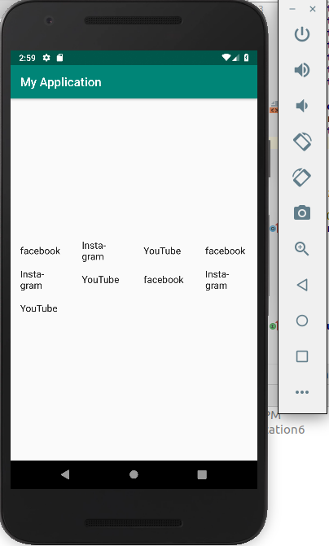

4.) Menu

xml

<?xml version="1.0" encoding="utf-8"?>
<android.support.constraint.ConstraintLayout xmlns:android="http://schemas.android.com/apk/res/android"
xmlns:app="http://schemas.android.com/apk/res-auto"
xmlns:tools="http://schemas.android.com/tools"
android:layout_width="match_parent"
android:layout_height="match_parent"
tools:context=".MainActivity">
<TextView
android:layout_width="wrap_content"
android:layout_height="wrap_content"
android:text="Hello World!"
android:id="@+id/tv"
app:layout_constraintBottom_toBottomOf="parent"
app:layout_constraintLeft_toLeftOf="parent"
app:layout_constraintRight_toRightOf="parent"
app:layout_constraintTop_toTopOf="parent" />
</android.support.constraint.ConstraintLayout>

java
package com.example.sjcet.myapplication;
import android.support.v7.app.AppCompatActivity;
import android.os.Bundle;
import android.view.Menu;
import android.view.MenuItem;
import android.widget.TextView;
import android.widget.Toast;
public class MainActivity extends AppCompatActivity {
TextView tv;
@Override
protected void onCreate(Bundle savedInstanceState) {
super.onCreate(savedInstanceState);
setContentView(R.layout.activity_main);
tv=(TextView)findViewById(R.id.tv);
String msg=getIntent().getStringExtra("mykey");// receiving the data
tv.setText(msg); // display(welcom changing to admin)
}
@Override
public boolean onCreateOptionsMenu(Menu menu) {
getMenuInflater().inflate(R.menu.main_menu,menu); //connecting menu
return true; // changing to true
}
@Override
public boolean onOptionsItemSelected(MenuItem item) {
switch (item.getItemId()) {
case R.id.emergency: // full colon
Toast.makeText(this," Emergency clicked",Toast.LENGTH_SHORT).show();
break;
case R.id.profile:
Toast.makeText(this," Profile clicked",Toast.LENGTH_SHORT).show();
break;
case R.id.aboutus:
Toast.makeText(this," About us clicked",Toast.LENGTH_SHORT).show();
break;
case R.id.signout:
Toast.makeText(this," Signout clicked",Toast.LENGTH_SHORT).show();
break;
}
return true;// changing to true
}
}

main_menu

<?xml version="1.0" encoding="utf-8"?>
<menu xmlns:android="http://schemas.android.com/apk/res/android">
<item
android:id="@+id/emergency"
android:title="emergency"/>
<item
android:id="@+id/profile"
android:title="profile"/>
<item
android:id="@+id/aboutus"
android:title="aboutus"/>
<item
android:id="@+id/signout"
android:title="signout"/>
</menu>

OUTPUT

